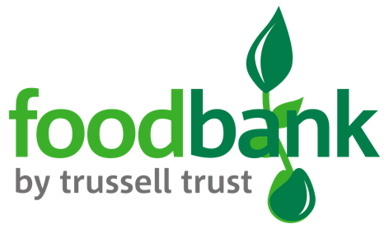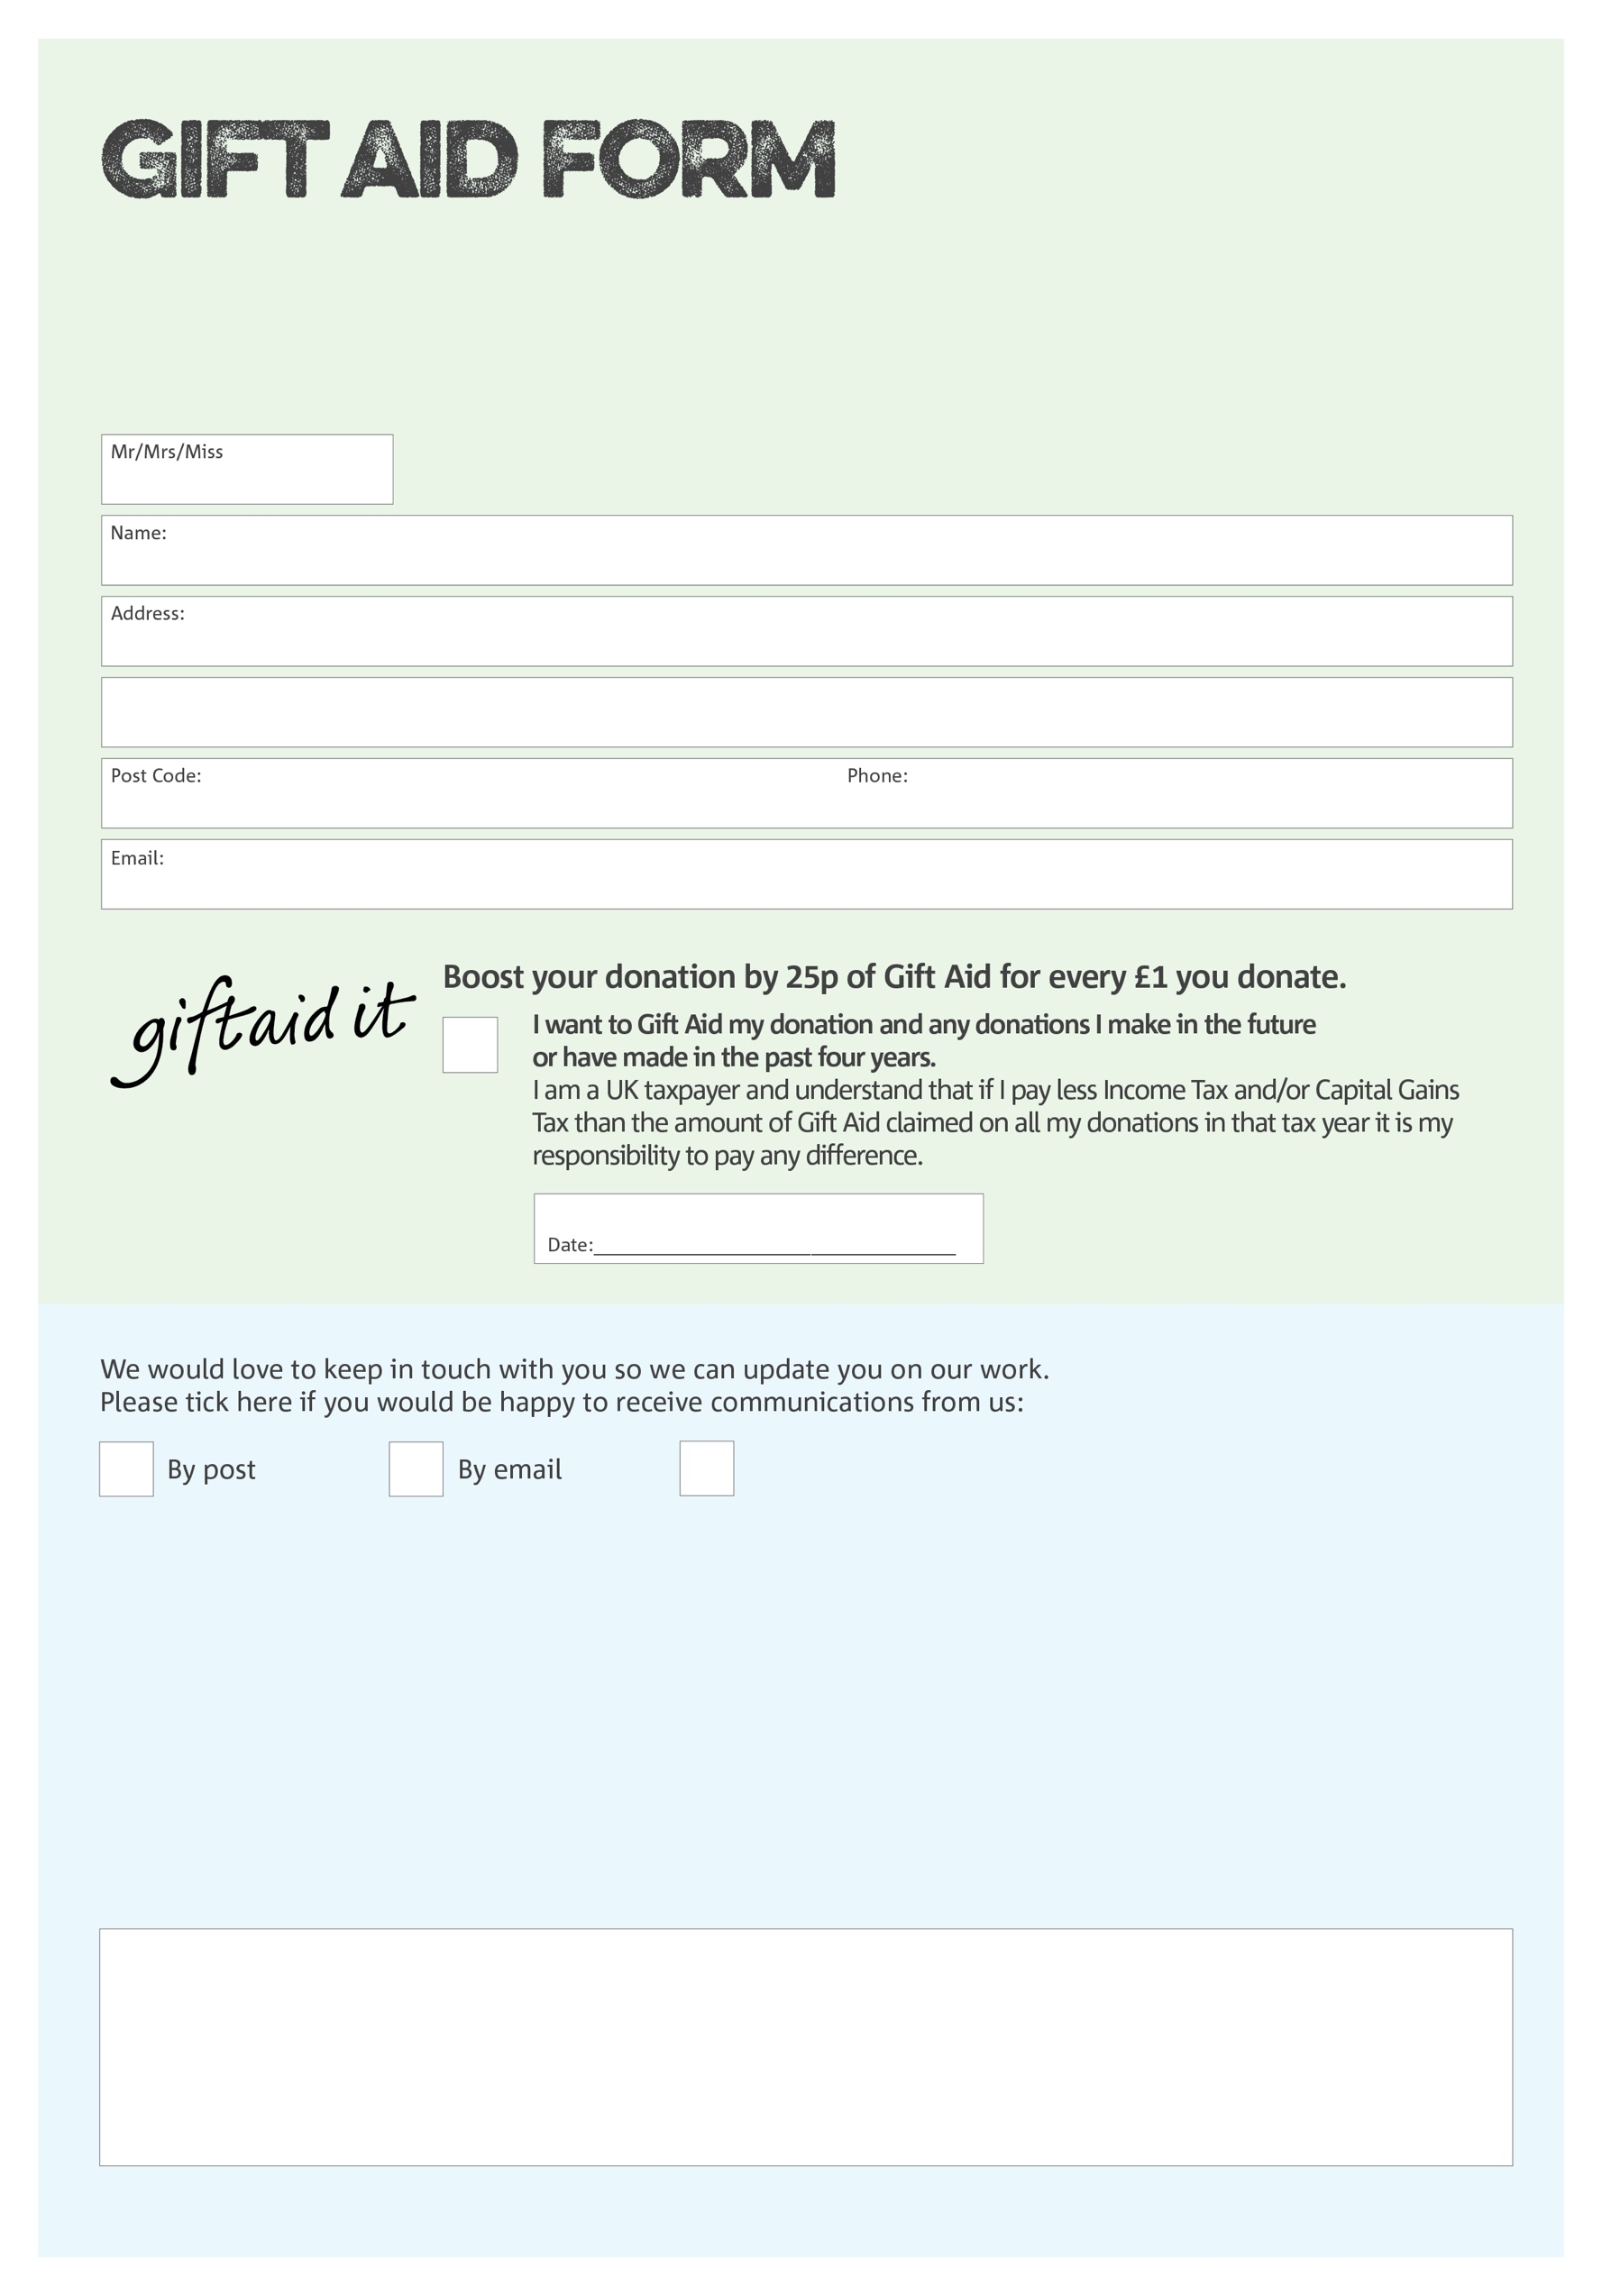

By filling in this form Dunstable Foodbank will receive an extra 25p for every £1 you give at no extra cost to you. Thank you!

**Data protection**

*'Dunstable Foodbank is committed to protecting your privacy and will process your personal data in accordance with current Data Protection legislation. Dunstable Foodbank collects information to keep in touch with you and supply you with information relating to our work. To unsubscribe from our newsletter, send a message to the email address above with the word unsubscribe in the subject line. A full data privacy statement for financial donors is available from the foodbank on request.’*

Charity Number 1148632. Registered in England & Wales

We would love to know why you have chosen to donate to Dunstable Foodbank. If you would like to share your motivation let us know below:

You can change your preferences any time by contacting us on 07874 200056 or emailing us at

opsmgr@dunstable.foodbank.org.uk

I do not wish to receive future communications from Dunstable Foodbank